Case Study / Scenario

Student ID1: 23-52361-2  Name: NAYEM SIDDIKI | StudentID3: 23-50713-1  Name: MD. ABDUR RAUF
StudentID2: 23-52314-2  Name: FARHAN CHOWDHURY | StudentID4: 23-52586-2  Name: MD AL MURSALIN
CO2: Understand the fundamental concepts underlying database systems and gain hands-on experience with ER diagram Case study
PO-c2: Develop process for complex computer science and engineering problems considering cultural and societal factors. |  | Marks

Bus Ticket Management System
In a Bus Ticket Management System, buses are identified by details such as a Bus number, seating capacity, type (like AC or non-AC), and the driver's name. Each bus is assigned to a specific route, which includes information like route NO, starting point, destination and total distance. Passengers are identified by their Passenger ID, along with personal details such as their name, contact number and e-mail. These passengers can book tickets for different bus routes. Each ticket is associated with a particular passenger and contains important details such as a ticket number, the travel date, the seat number assigned, and the status of the ticket (whether it’s booked, confirmed, or canceled). The system ensures that each bus operates on a specific route, while passengers can book multiple tickets for different journeys. Multiple passengers can book seats on the same bus, and the system organizes all the information, ensuring smooth travel arrangements.

ER Diagram
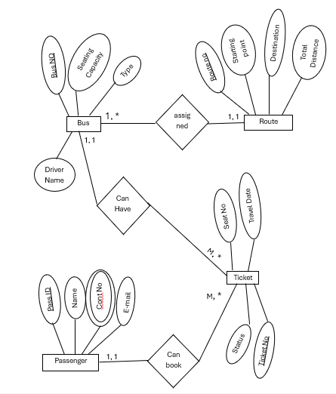

Normalization
1NF Table
Ticket_No | Bus_No | Seating_Capacity | Type | Driver_Name | Route_No | Start_Point | Destination | Passenger_ID | Passenger_Name | Contact_No | Travel_Date | Seat_No | Status
T001 | 001 | 50 | AC | John Doe | 101 | City A | City B | P001 | Alice Green | 1234567890 | 2024-09-18 | 10 | Confirmed
T002 | 001 | 50 | AC | John Doe | 101 | City A | City B | P002 | Bob Brown | 0987654321 | 2024-09-18 | 12 | Booked
T003 | 002 | 40 | Non-AC | Jane Smith | 102 | City C | City D | P003 | Carol White | 1122334455 | 2024-09-19 | 5 | Confirmed
T004 | 002 | 40 | Non-AC | Jane Smith | 102 | City C | City D | P004 | David Black | 6677889900 | 2024-09-19 | 8 | Canceled
T005 | 003 | 55 | AC | Mike Green | 103 | City E | City F | P005 | Eve Brown | 2233445566 | 2024-09-20 | 15 | Booked

2NF Table
Table: 1
Ticket_No | Passenger_ID | Travel_Date | Seat_No | Status | Bus_No | Route_No | Passenger_ID | Passenger_Name | Contact_No
T001 | P001 | 2024-09-18 | 10 | Confirmed | 001 | 101 | P001 | Alice Green | 1234567890
T002 | P002 | 2024-09-18 | 12 | Booked | 001 | 101 | P002 | Bob Brown | 0987654321
T003 | P003 | 2024-09-19 | 5 | Confirmed | 002 | 102 | P003 | Carol White | 1122334455
T004 | P004 | 2024-09-19 | 8 | Canceled | 002 | 102 | P004 | David Black | 6677889900
T005 | P005 | 2024-09-20 | 15 | Booked | 003 | 103 | P005 | Eve Brown | 2233445566

Table: 2
Bus_No | Seating_Capacity | Type | Driver_Name | Route_No | Start_Point | Destination | Total_Distance
001 | 50 | AC | John Doe | 101 | City A | City B | 200 km
002 | 40 | Non-AC | Jane Smith | 102 | City C | City D | 150 km
003 | 55 | AC | Mike Green | 103 | City E | City F | 300 km

Finalization
3NF Table
Table 1: Ticket Table
Ticket_No | Passenger_ID | Travel_Date | Seat_No | Status | Bus_No | Route_No
T001 | P001 | 2024-09-18 | 10 | Confirmed | 001 | 101
T002 | P002 | 2024-09-18 | 12 | Booked | 001 | 101
T003 | P003 | 2024-09-19 | 5 | Confirmed | 002 | 102
T004 | P004 | 2024-09-19 | 8 | Canceled | 002 | 102
T005 | P005 | 2024-09-20 | 15 | Booked | 003 | 103

Table 2: Bus Table
Bus_No | Seating_Capacity | Type | Driver_Name
001 | 50 | AC | John Doe
002 | 40 | Non-AC | Jane Smith
003 | 55 | AC | Mike Green

Table 3: Route Table
Route_No | Start_Point | Destination | Total_Distance
101 | City A | City B | 200 km
102 | City C | City D | 150 km
103 | City E | City F | 300 km

Table 4: Passenger Table
Passenger_ID | Passenger_Name | Contact_No
P001 | Alice Green | 1234567890
P002 | Bob Brown | 0987654321
P003 | Carol White | 1122334455
P004 | David Black | 6677889900
P005 | Eve Brown | 2233445566

